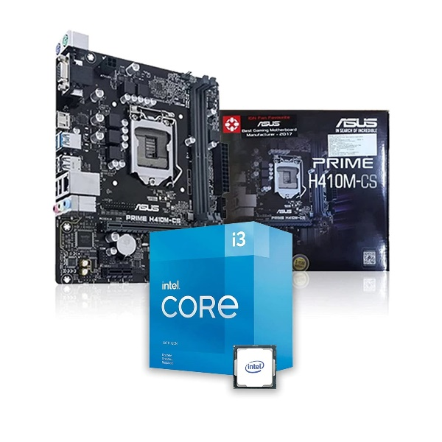

Inner

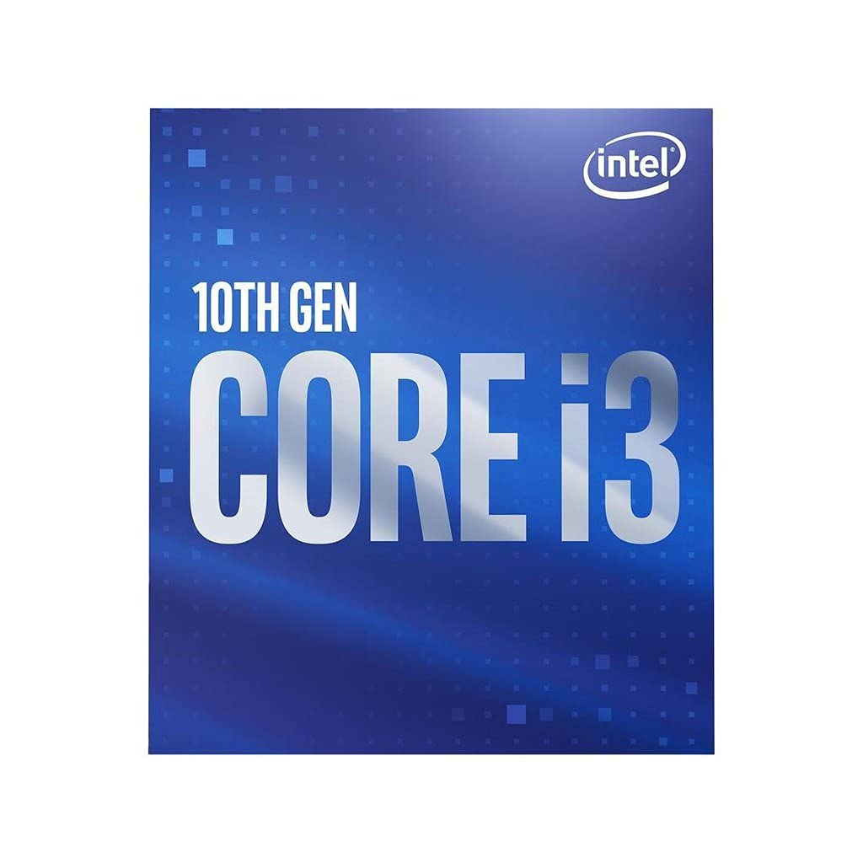

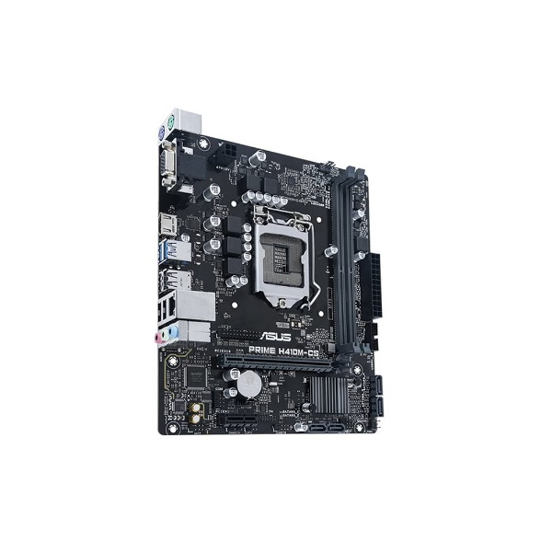

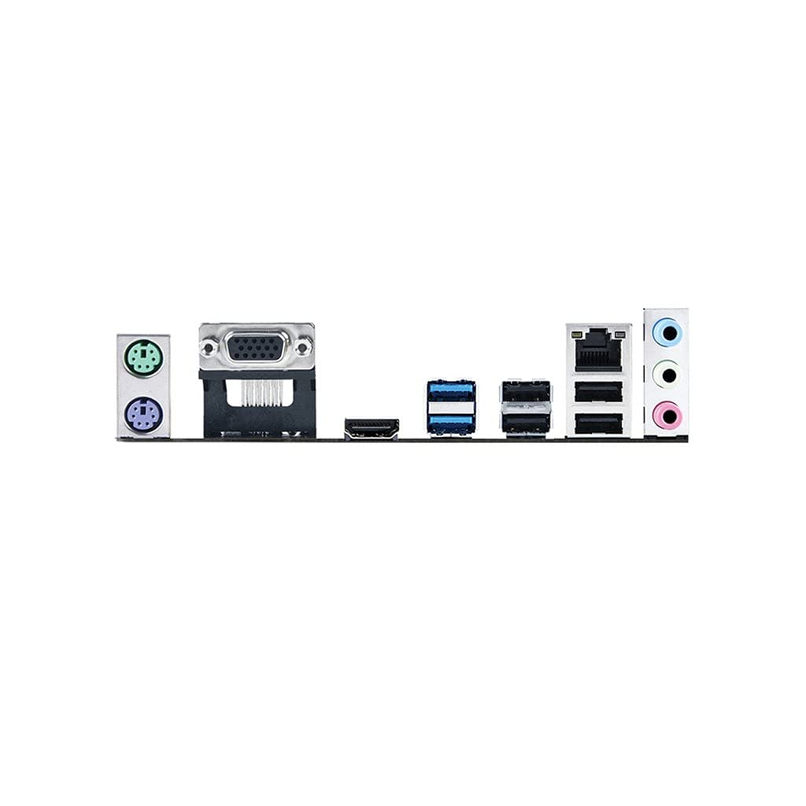

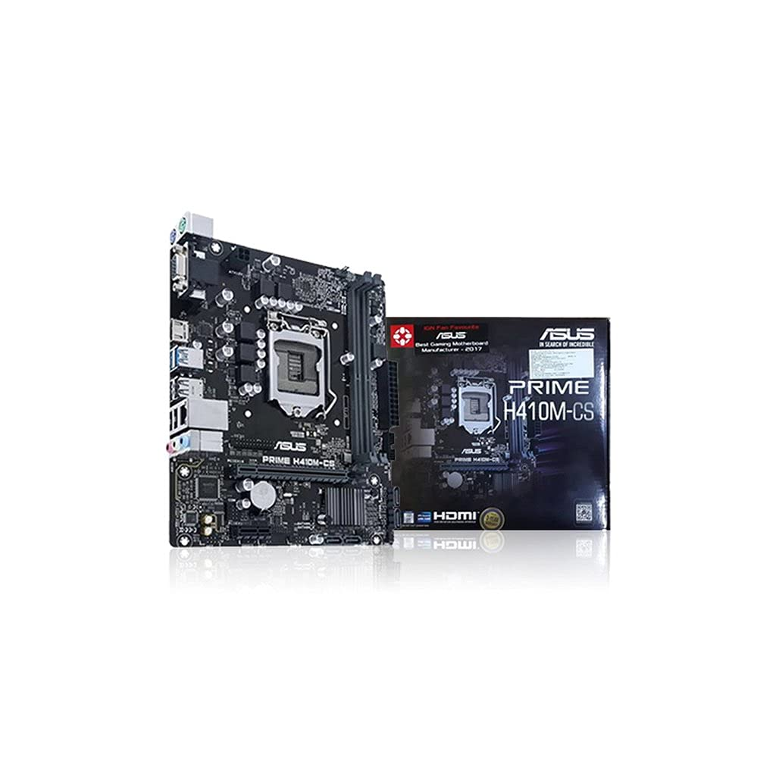

Intel Core i3-10105F LGA1200 Desktop Processor 4 Cores 8 Threads up to 4.40GHz 6MB Cache Bundled with Prime H410M-CS LGA 1200 Micro-ATX Motherboard

-23% ₹14,760.00₹14,760.00

M.R.P.: ₹19,200.00₹19,200.00

|  |  |
| --- | --- |
| Brand | Intel |
| CPU Manufacturer | Intel |
| CPU Model | Core i3 |
| CPU Speed | 3.7 GHz |
| Secondary Cache | 6 MB |

**About this item**

* Introducing the 10th Gen Intel Core i3 desktop processor, this processor is 14 nm processor which supports LGA 1200. The Processors features 4 Core which allow the processor to run multiple programs simultaneously without slowing down the system, while the 8 threads allow instructions to be handled by a single CPU core alomg with Hyper Threading Technology.
* With 3.70GHz Base frequency, the Intel Turbo Boost 2.0 technology cranks maximum turbo frequency up to blazing 4.40 GHz. The processor is desirable for a gamer looking for a fantastic in-game experience and a creator that is ready to do more creating and sharing alike.
* All this paired with 6MB of Intel Smart Cache. It has a TDP rating of 65W with max memory size of 128GB dual-channel DDR4 support for up-to 2666Mhz with Intel top notch security features.
* ASUS Prime H410M-CS motherboard is designed to support the 10th Gen Intel Core processors with DDR4 memory up to 64GB with Dual Channel Memory Architecture.
* Prime H410 series is engineered with an array of hybrid fan headers to ensure your rig stays cool and stable under intense workloads. Fan Xpert software provides comprehensive control over system fans.